Scott Tabaka
Instructor: Badri Adhikari
CmpSci 4300 Fall 2019
Due Date: 11/21/2019

Homework #4

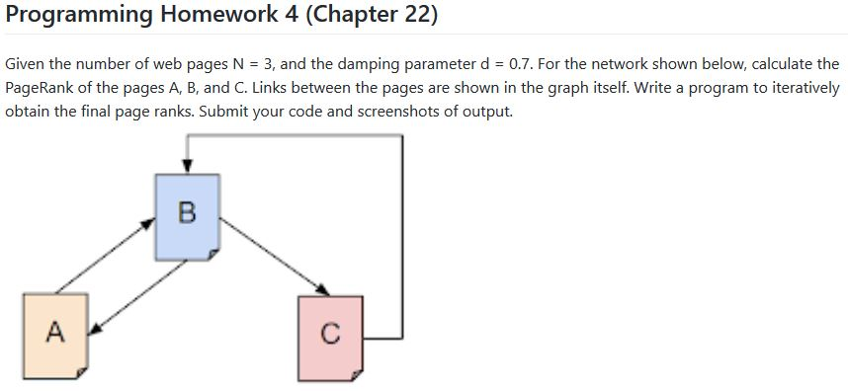

Java code:
public class PageRank
{
public static void main(String[] args)
{
double d = 0.7, N = 3, A = 1, B = 1, C = 1;
double E = calcE(d,N);
for (int i = 0; i < 20; i++)
{
A = E + (d * (B / 2));
B = E + (d * (A + C));
C = E + (d * (B / 2));
}
System.out.println("PageRank(A):" + A + "\nPageRank(B):" + B + "\nPageRank(C):" + C);
}
private static double calcE(double d, double N)
{
return ((1-d)/N);
}
}
Output:
